Level 1
We Build a basic cenary , a ground, a flag and some GameObjets, BrickBlock, CuriousBlock, Token, PowerUp, Player1 and Player2, matching they own materias and making hitbox it box colliders on the blocks. (Fig1).​​
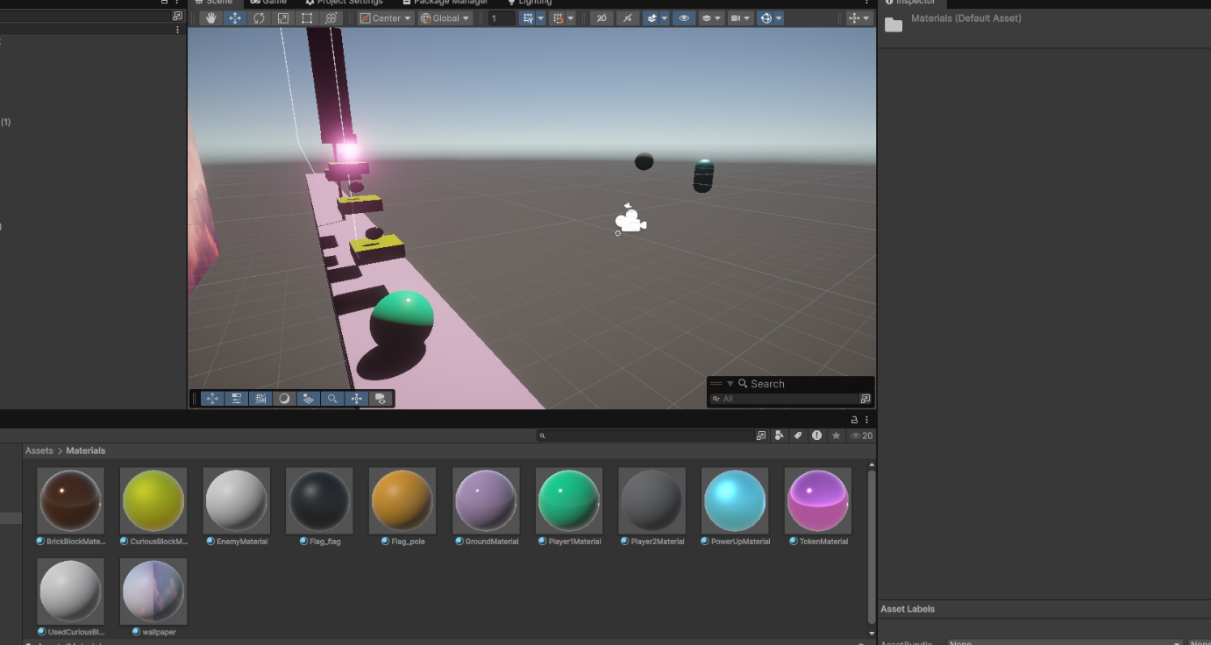

Fig.1

Level 2
We created a Canvas with two TextMeshPro elements (ScoreText and LivesText) and positioned them using anchors (Fig. 2). We created the UIManager script with score and lives variables, linked it to the Canvas texts, and implemented the Awake, AddScore, UpdateScoreUI, SetLives, and UpdateLivesUI methods to manage score and lives in a centralised way (Fig. 3).
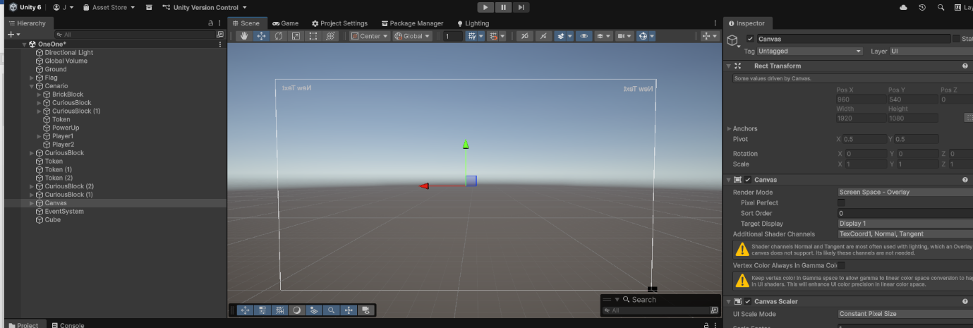

Fig.2

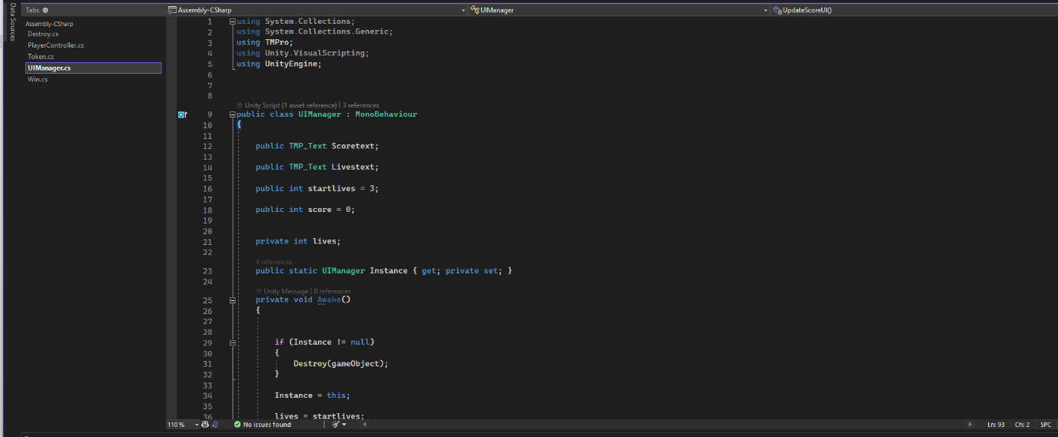

Fig.3

Level 3
We programmed the player’s movement in the PlayerController script, defining movement variables, jump, ground detection, Rigidbody, a groundCheck Transform, and the ground LayerMask (Fig. 4). In Awake, we initialise the Rigidbody and freeze its rotation. In Update, we read the horizontal input and the jump command, and in FixedUpdate we calculate isGrounded with Physics.CheckSphere, limit the speed, and in the Jump method we apply an instant vertical force for the jump (Fig. 5).
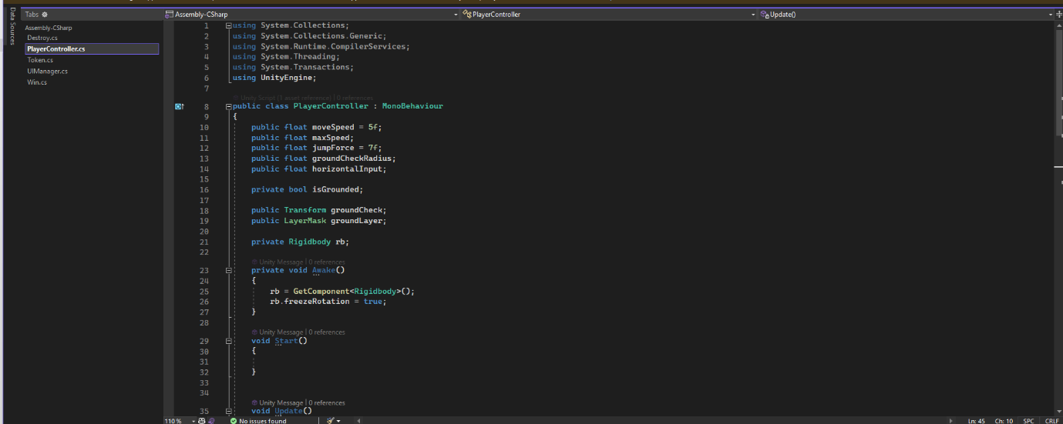

Fig.4

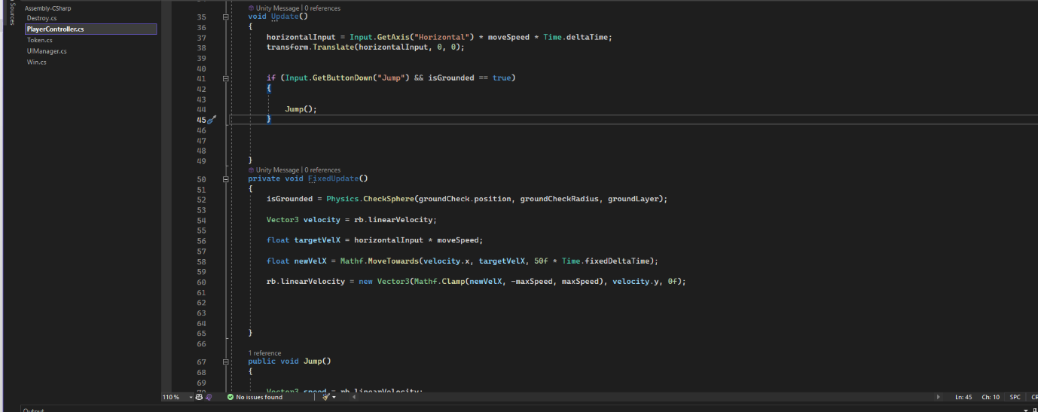

Fig.5

Level 4
We created the Token script, which has a Collider set as a trigger and an added, configured AudioSource (Fig. 6). In OnTriggerEnter, when the player with the tag ‘Player’ enters the trigger, we use the UIManager to increase the score, play the pickupSfx sound if it exists, and destroy the Token, also ensuring that the ground is on the ‘Ground’ Layer and all objects use the correct Materials (Fig. 7).
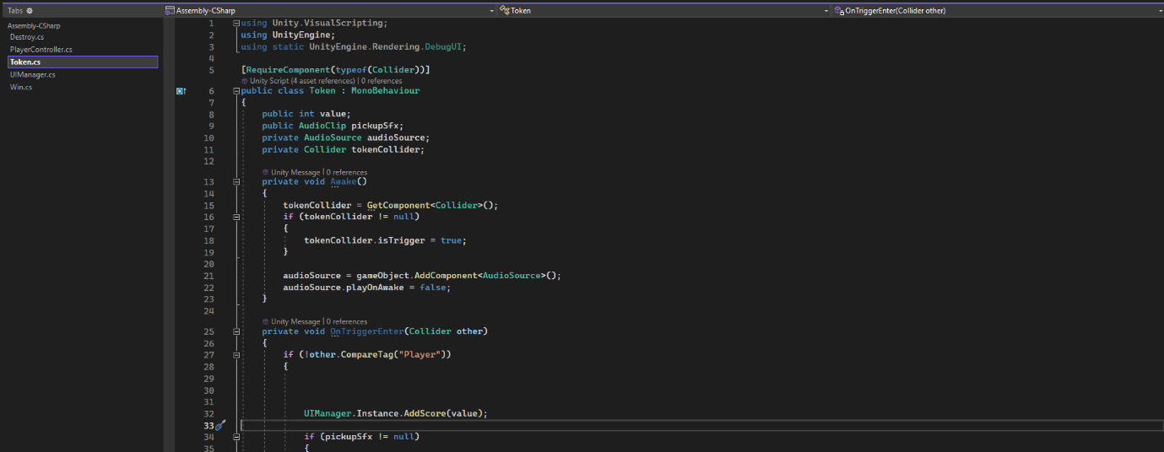

Fig.6
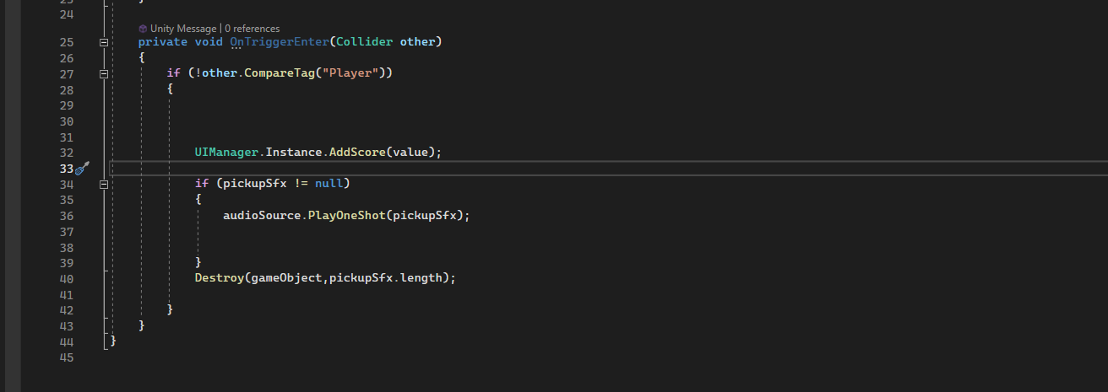

Fig.7

Level 5
In this level, it is simply about creating a level as we wish, and we may use other scripts from previous Labs we worked on in class.
Scripts we also created to complement the level:
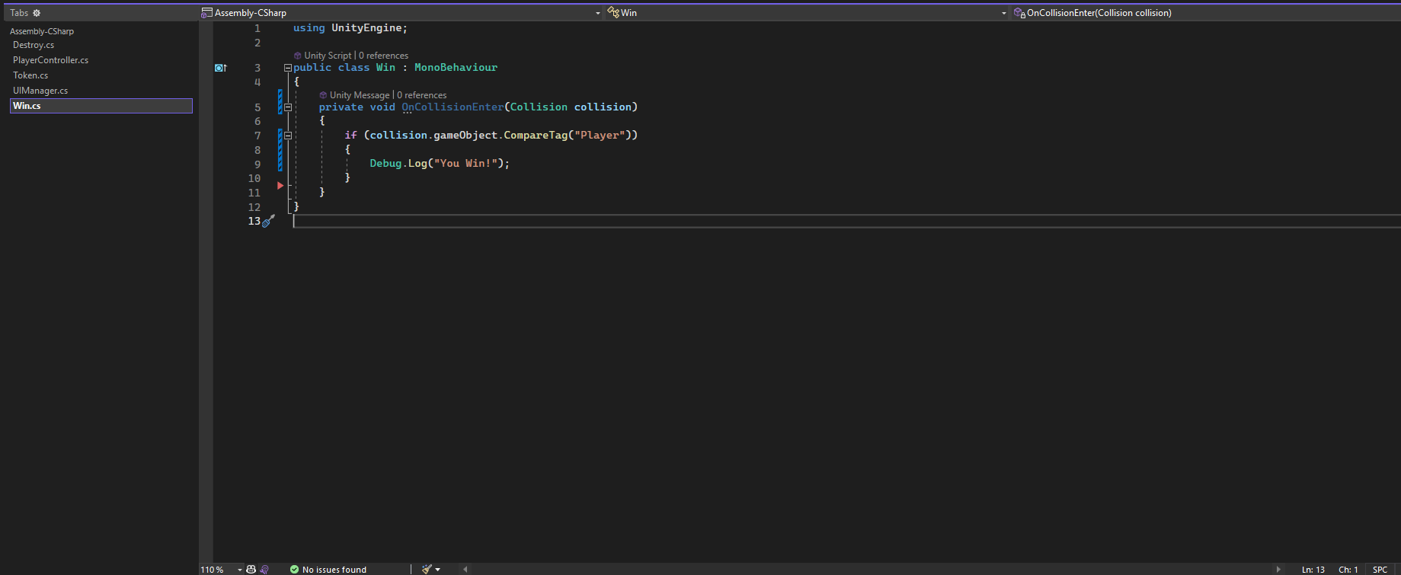
Fig.8
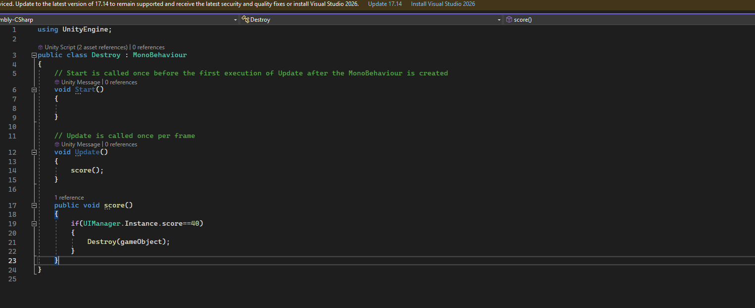
Fig.9

